
BOSTON
INTERNATIONAL COLLEGE
END TERM EXAM
Level: Bachelor |  | Year : 2023
Program: BCIS Sem: II |  | Full Marks : 100
Course: Object Oriented Language (Java) |  | Time : 3 hrs

Candidates are required to give their answers in their own words as far as practicable. The figures in the margin indicate full marks.

Group A
Very Short Answer Questions
Attempt all the questions. Give your answer in few lines: 10*2=20
- Why was Swing developed even though AWT was enough for GUI programming in Java?
- Prove why Java is an architecturally neutral language.
- Define a deadlock scenario.
- Differentiate instance and static variable.
- What is the use of the super keyword in Java? List any 3 uses.
- Write a program to generate random integer values up to 10.
- What do you mean by Auto-boxing and Auto-unboxing?
- What is the difference between using isAlive() and stop() method?
- What is finally used for?
- What is the purpose of SimpleDateFormat class in Java?

Group B
Descriptive Answer Questions
Attempt any six questions. 6*10=60
- What is an Exception? Write a program to create a custom exception (UserNotFoundException) to check if a user exists in an ArrayList named users.
- What are HashMap and HashSet? Write a program to show the differences
- Why final and abstract cannot be used at a time? Write a program to show inheritance in the interface.
- What is the event delegation model in Java? What are the terminologies used in event handling? Write a program to demonstrate an event handling when a button is pressed consider the necessary criteria yourself.

  - What are collections? Explain the uses of Array List with an example.
  - Write a program that takes two strings from user and check whether they are identical or not.

  - What is wrapper class? Explain wrapper classes available in Java.
  - What is multithreading? Explain the life cycle of the thread.

Group C
Case Analysis (20)
- You are approached by Baba Travels to develop a system that helps for selling Bus tickets. They have asked to name the system “Marvel V1.0”. You are required to develop the system which includes login and sales form according to the figure as follows.

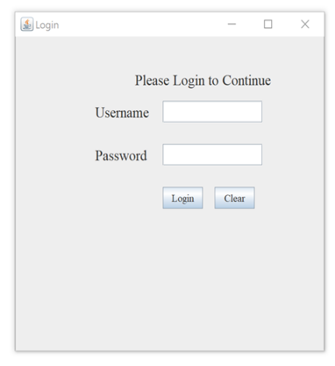
Figure 1. Login Dialog

- Design Login Dialog same as in Figure 1. When the login button is clicked if the correct username and password are supplied then the sales dashboard is shown otherwise “Wrong Username or Password” is alerted in Dialog

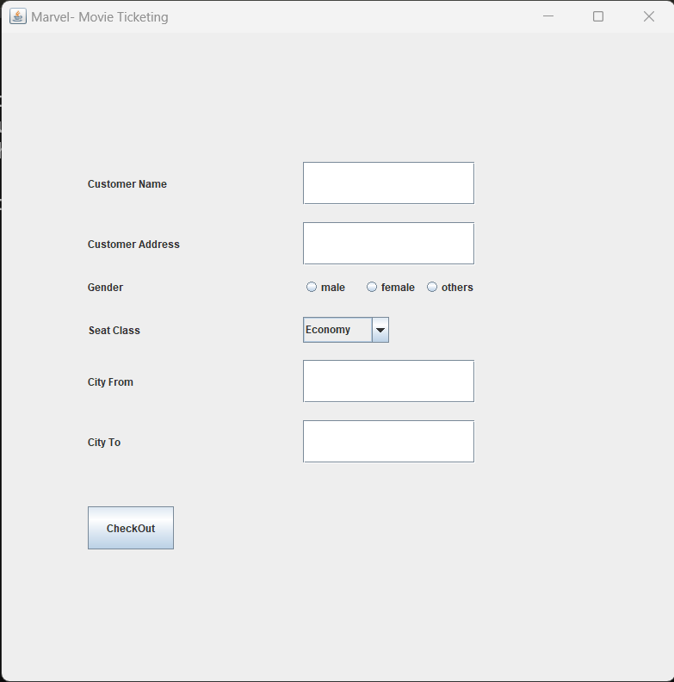
Fig 2. Sales

- Design the sales form as in Figure 2. If the user fills in all the data and presses the checkout button then a dialog is alerted with the message "purchase successful". After that, all the details are printed in the Console Window.

